**Luis Munoz**

**(1) the results of the query –**

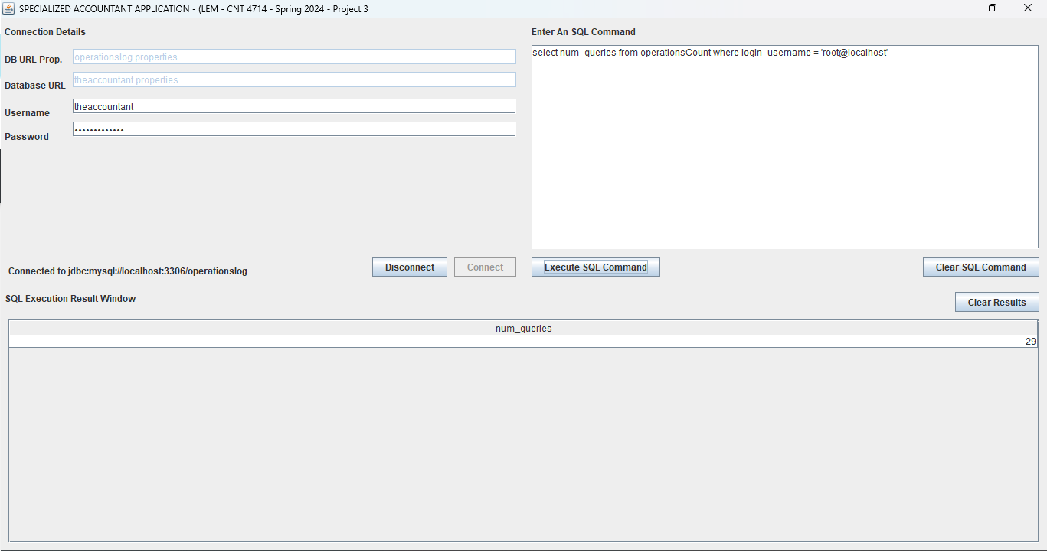

**(2) select * from operationscount ;**

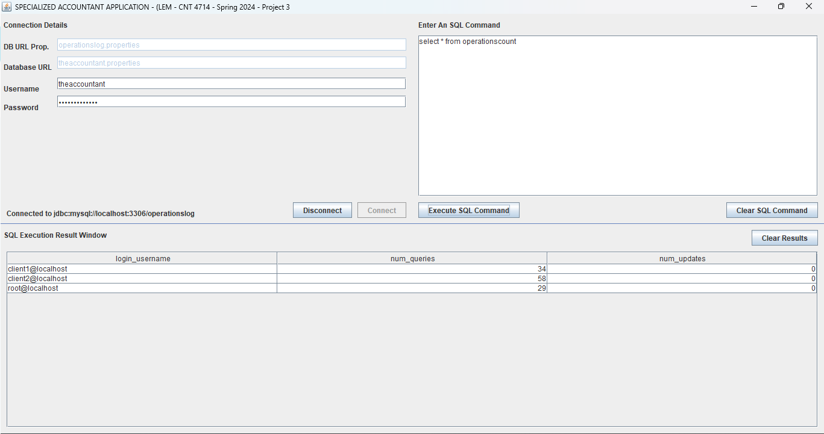

**(3) select * from operationscount;**

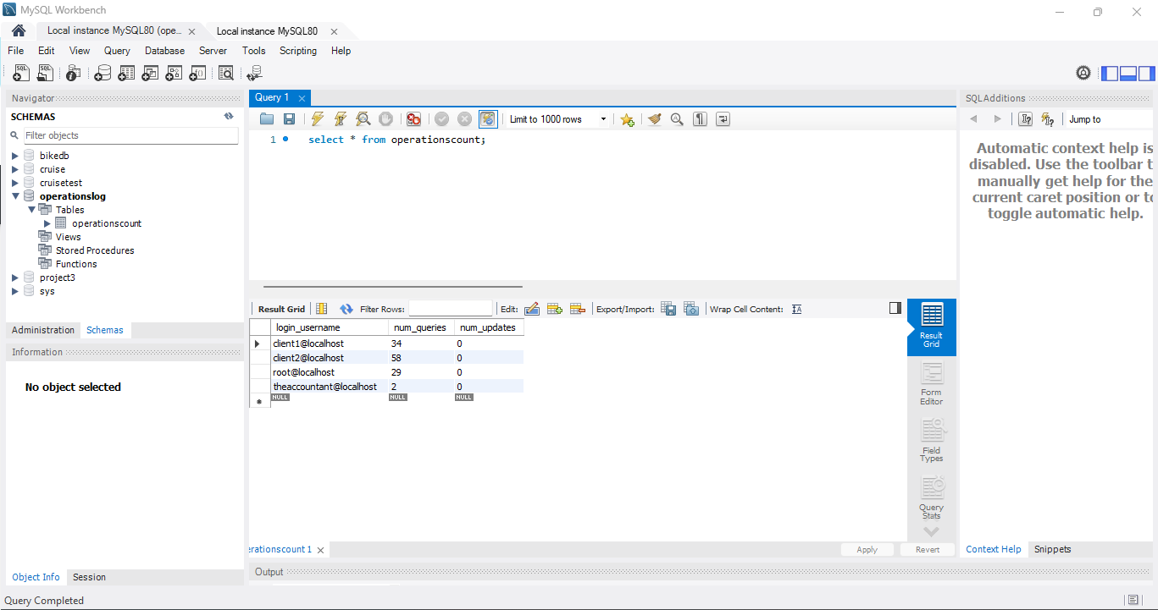

**(4)A screenshot showing a mismatch between the user-entered credentials and the selected properties file resulting in no connection to the database being established.**

**The client application:**

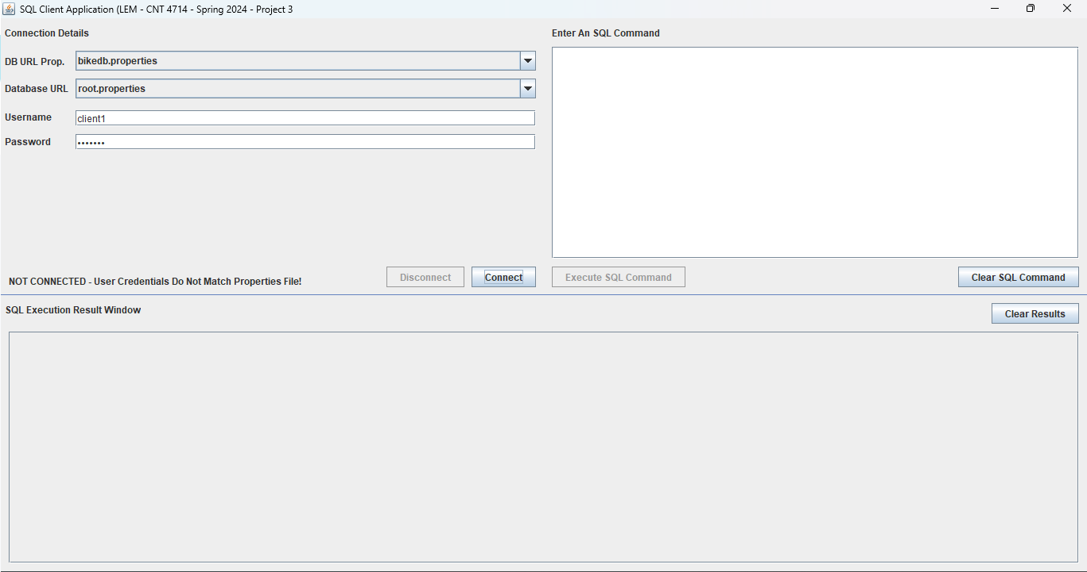

**The accountant application:**

